40.43: a) For a free particle, 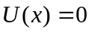 so 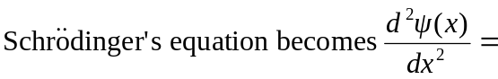
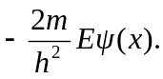
See graph below.
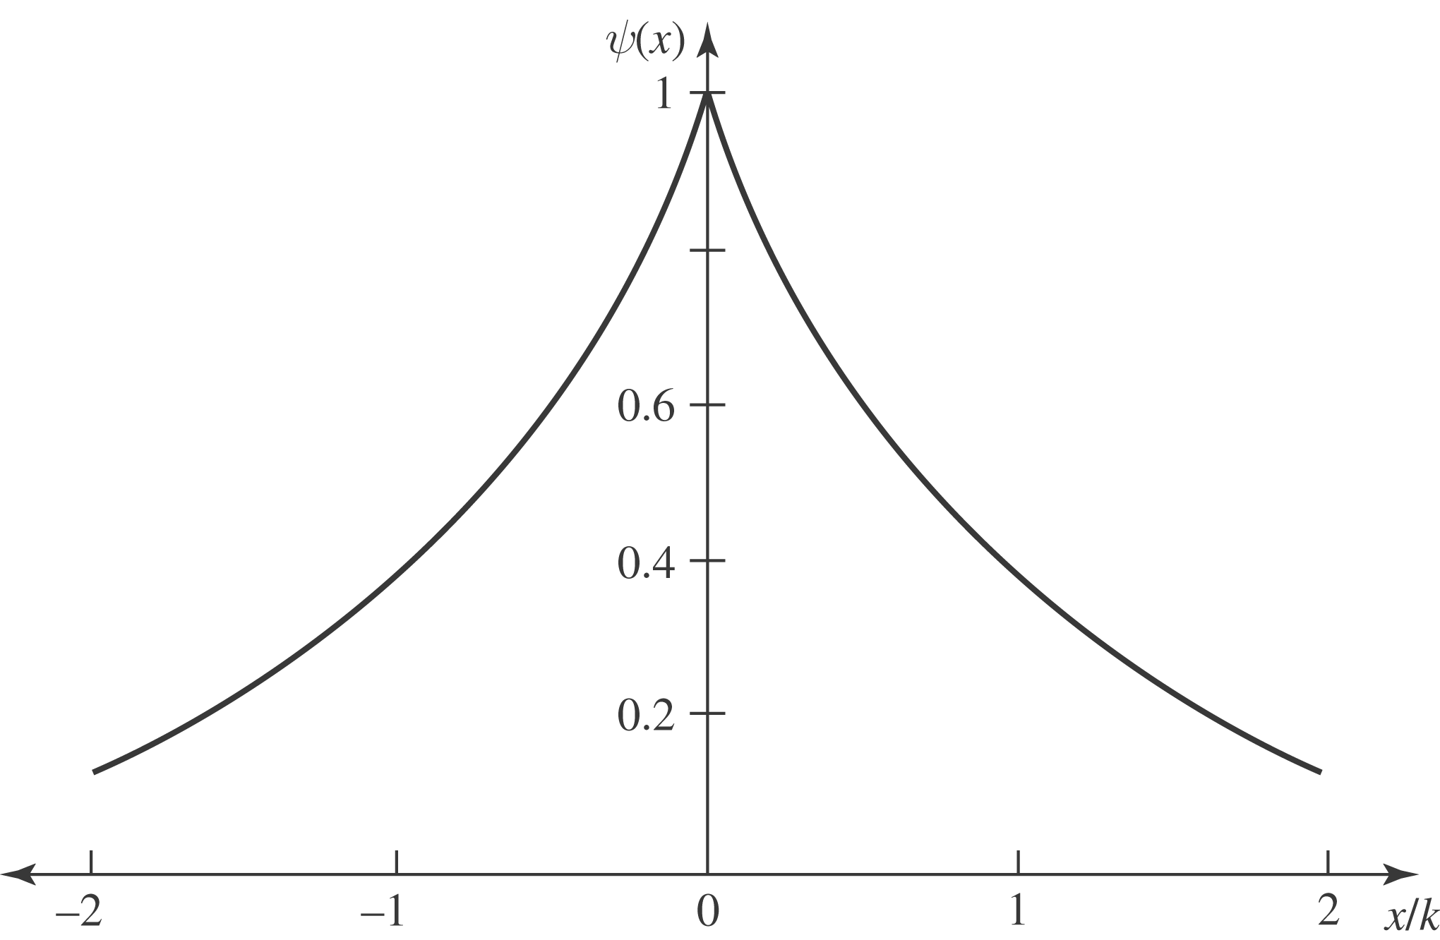

b) For x < 0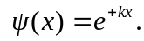
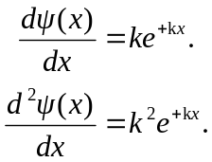
So 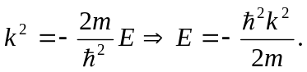
c) For x > 0 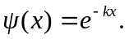
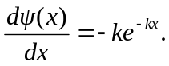
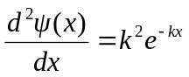
So again 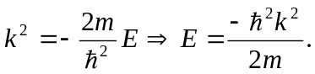
Parts (c) and (d) show 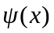 satisfies 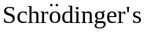 equation, provided 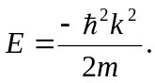
d) Note 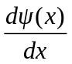 is discontinuous at

